Plan De Apoyo Comprensión Ingles
- Read:
The Little Kite
Tom was a little boy. He loved making kites. One sunny afternoon, he made a blue kite with his grandfather.
Tom went to the park to fly his kite. At first, the kite did not fly very high. Tom felt sad.
His grandfather helped him hold the string. Soon, the wind became stronger and the kite flew high in the sky.
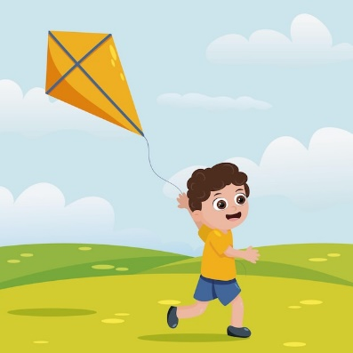
Tom smiled and said, “I did it!”

📖 Lectura
- Lectura silenciosa.
- Lectura en voz alta (pronunciación).
- Lectura guiada por la Miss

📖 Reading comprehension

1. What is the boy's name?
A. Ben
B. Tom
C. Lucas
D. David

2. What did Tom make?
A. A kite
B. A boat
C. A toy
D. A car

3. What color was the kite?
A. Red
B. Yellow
C. Green
D. Blue

4. Where did Tom go?
A. School
B. Home
C. Park
D. Store

5. Who helped Tom?
A. His friend
B. His grandfather
C. His teacher
D. His brother

🖼️ Reading comprehension
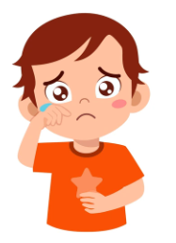
6. How did Tom feel when the kite did not fly?
A. Happy
B. Sad
C. Angry
D. Tired


7. What helped the kite fly higher?
A. Rain
B. Sun
C. Wind
D. Snow

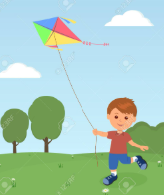
8. Why did the kite fly higher?
A. Tom ran home.
B. The wind became stronger.
C. It started to rain.
D. Tom bought a new kite.

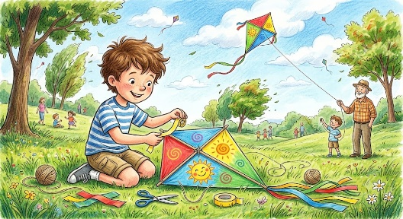
9. What happened first?
A. The kite flew high.
B. Tom made a kite.
C. Tom smiled.
D. Tom went home.


10. How did Tom feel at the end?
A. Sad
B. Angry
C. Scared
D. Happy


⭐ Vocabulary

Match the word with the picture.
Kite

Grandfather
Park

Wind
Sky


✍️ Writing

Parte 1: Complete the sentence
- My name is __________.
- I am __________ years old.
- I like __________.

Parte 2: Short answers
- What color was the kite?
- Who helped Tom?
- Where did Tom go?

Parte 3: One simple sentence
- Write one sentence about Tom.

👂 Listening + 🗣️ Speaking
Lee este texto una sola vez:
Lucy has a small dog. Every afternoon she goes to the park with her dog. They like to play with a ball. Lucy is very happy when she plays with her dog.
- What animal does Lucy have?

- Where does Lucy go?

- What do they play with?

- Is Lucy happy or sad?

🗣️ Speaking
- Do you like dogs?
- What is your favorite animal?
- Are you happy today?

